**Identified Pattern: FakeDoc_variety1**

**The name of the identified app: ServeStream**

**The name of the identified sample app: Battery SuperCharger**

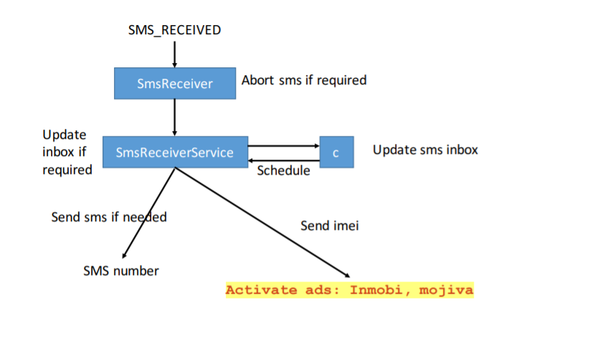

**For functional modules:**

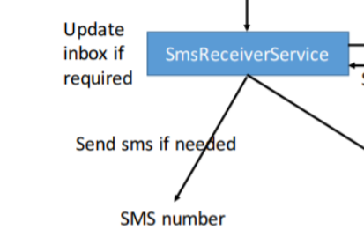

**Corresponding to the code in sample:：**

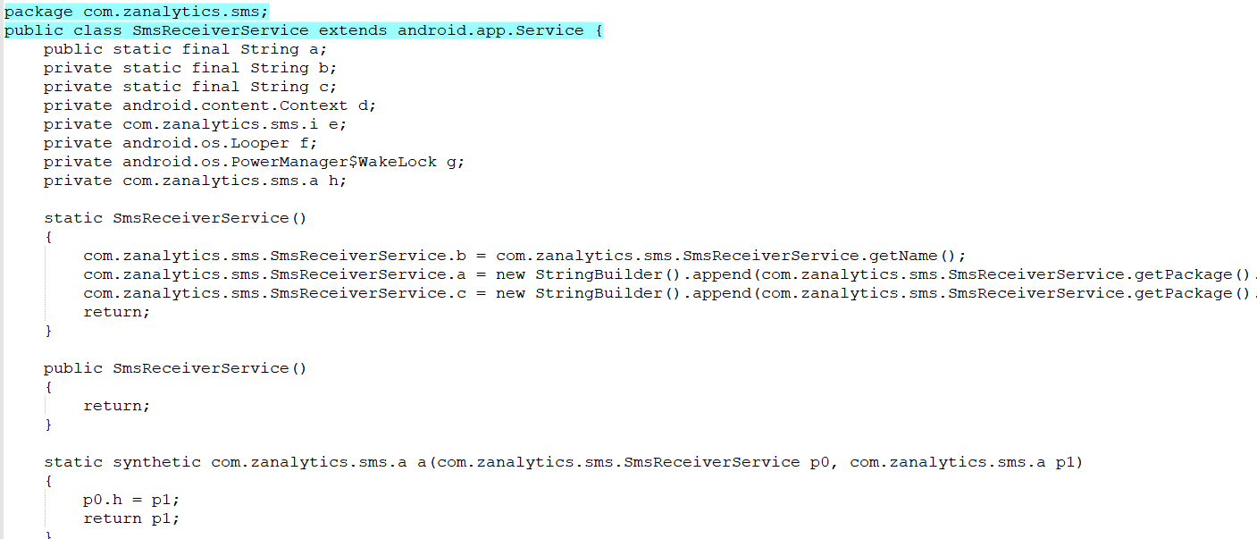

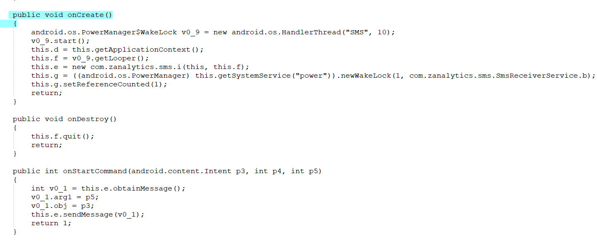

**Corresponds to the code in the identified app:**

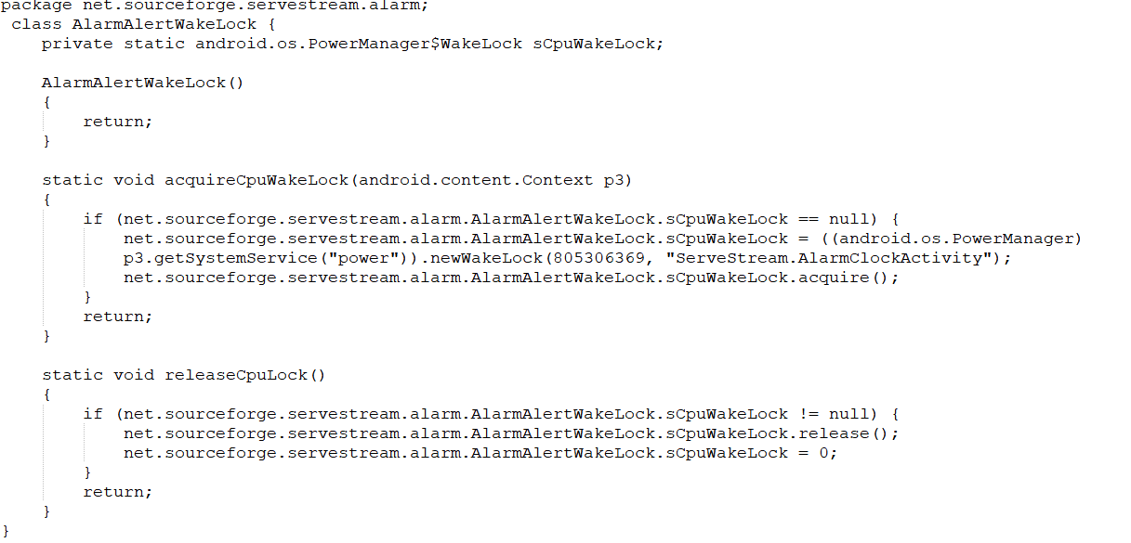

**The corresponding key code in sample app:**

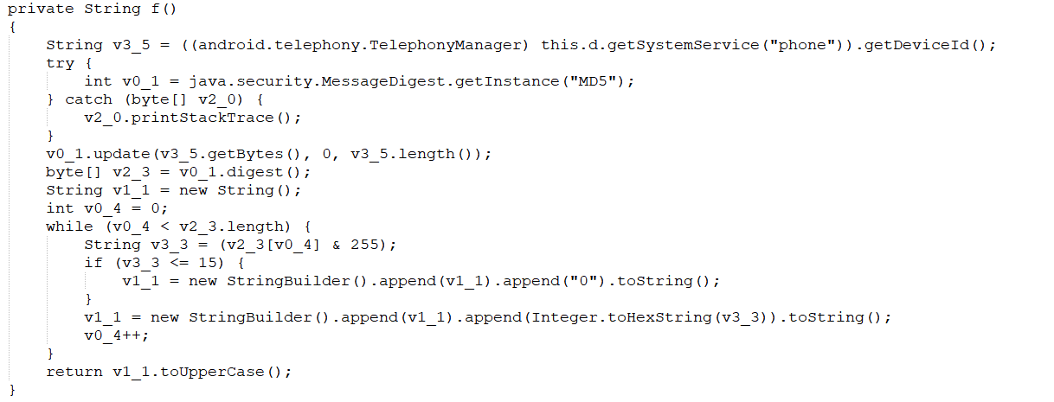

**The corresponding key code in the identified app:**

